Name | Using GDB – Simple
Challenge | Use GDB to debug a c source file.
Prereqs | Basic c understanding.
Narrative | GDB is a command line debugger. It allows a user to step through a file and view variable information as it changes.  View https://sourceware.org/gdb/current/onlinedocs/gdb/ for more information on gdb.
Instructions | Step 1 – Install gdb  To install gdb use the following command on debian.  $ sudo apt-get install gdb  Step 2 – Create A .c File  (1) Create a simple c file.  $ gedit debugme.c  (2) Write some code in debugme.c file  #include <stdio.h>  int main(void)  {  int a = 3, b = 5, i = 0;  b = a*b;  a = b + a;  a = a * 4;  for (i=0; i < 100; i++) {  b = a*b;  }  return 0;  }  Step 3 – Compile the debugme.c File  Use gcc to compile debugme.c with debug and error information enabled. Also give it an output file name of debugme.out.  $ gcc debugme.c -g -Wall -o debugme.out  Step 4 – Launch gdb  Launch gdb with the debugme binary file in text user interface mode.  $ gdb debugme.out -tui  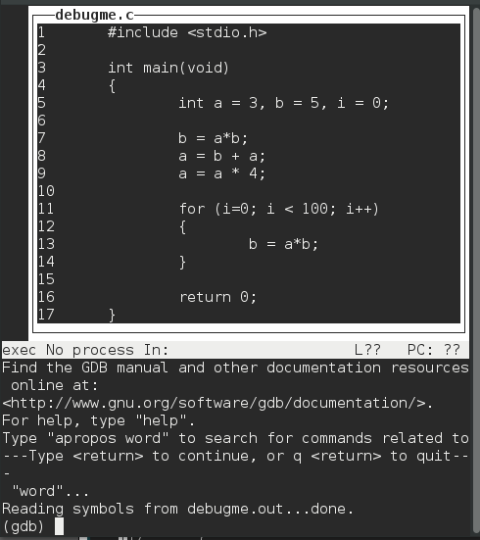  Note: You might need to press <enter> a couple times.  Note: To navigate the source file use the {up} and {down} arrows or the {scroll wheel}.  Step 5 – Example of Debugging the File  (1) Set a breakpoint on the function main  $ break main  (2) Run the program. The debugger will stop on main breakpoint  $ run  (3) Step to the next line  $ step  (4) View contents of the variable “b”  $print b  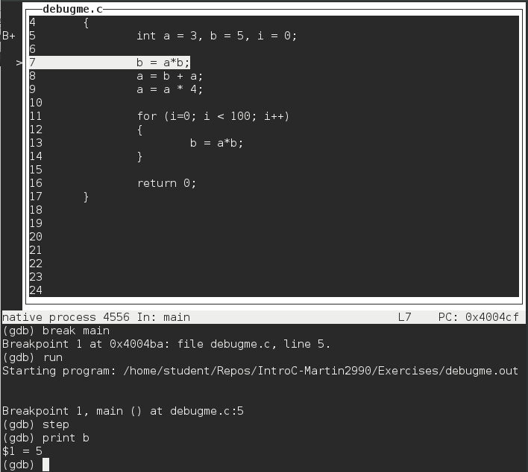  (5) Set a breakpoint on source code line 11  $ break 11  (6) Continue to run the program until it reaches the next breakpoint  $ continue  (7) Modify the value of variable “a” to be 4  $ set var a=4  (8) run the program until the end of the function  $ break 16  $ continue  (9) View all local variable contents  $ info locals  *Make note of the value of b.  (10) Close gdb  $ q  Question  What is the value of b at the end of the function after running the above commands?  Hash the answer and submit it to the server for 3 points.  Additional Notes  There is additional functionality not reviewed in this tutorial. Cheat sheets online can make utilizing commands easier and can expose additional functionality.

- Correct answer - (b=939)
89f549b2a5341a05a7e4afeb364599158a03a47f

- Wrong Answer - (b=16647)
You did not modify the value of variable “a.” Read the directions again.
0e9b868d1a8b2b00776bbf99e75cdca8f263ce98

